LAB-6.4
2303A51295
BATCH-10
TASK-1: Student Performance Evaluation System
PROMPT :
generate a python program to create the skeleton of python class named student Skeleton of Student class. Create a method to display student details including name, roll number and marks and display student details. Method to check performance based on class average
CODE:
# Skeleton of Student class
class Student:
def __init__(self, name, roll_number, marks):
self.name = name
self.roll_number = roll_number
self.marks = marks
# Create a method to display student details including name, roll number and marks
# Method to display student details
def display_details(self):
print("Student Name:", self.name)
print("Roll Number:", self.roll_number)
print("Marks:", self.marks)
# Method to check performance based on class average
def check_performance(self, class_average):
# Check if student's marks are above class average
if self.marks > class_average:
return "Performance is above class average"
else:
return "Performance is below or equal to class average"
# Sample usage
if __name__ == "__main__":
# Creating student objects
s1 = Student("Madhuri", 101, 85)
s2 = Student("Ravi", 102, 70)
# Assume class average
average_marks = 75
# Display details and performance
s1.display_details()
print(s1.check_performance(average_marks))
print("---------------------")
s2.display_details()
print(s2.check_performance(average_marks))
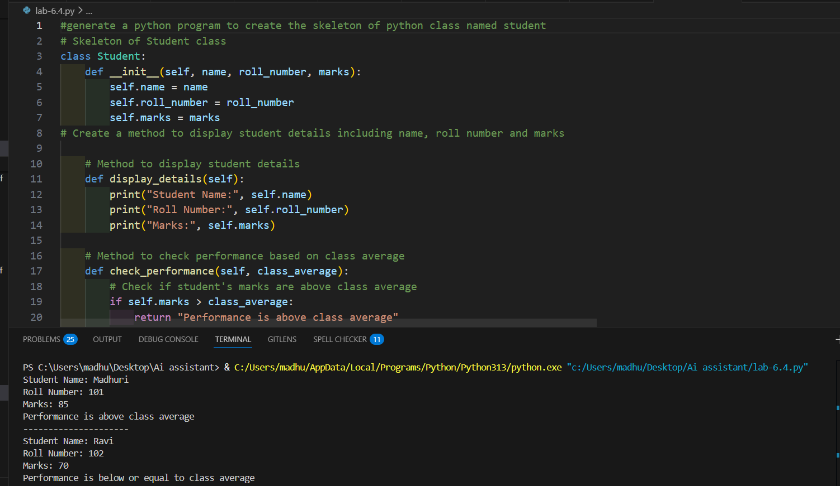
CODE ANALYSIS:
- The program creates a Student class with attributes name, roll number, and marks using the constructor.
- It includes methods to display student details and to compare marks with class average using an if-else condition.
- The output shows correct results for two students, proving the class and methods are working properly.

TASK-2: Data Processing in a Monitoring System
PROMPT :
Generate a code in python List of sensor readings collected from system. Identify whether the reading is an even number using modulus operator .If it is even, calculate the square of that reading Print the original reading and its square in a readable format
CODE:
# List of sensor readings collected from system
sensor_readings = [10, 15, 22, 7, 18, 30, 41, 56]:
# Identify whether the reading is an even number using modulus operator .If it is even, calculate the square of that reading Print the original reading and its square in a readable format
if reading % 2 == 0:
square = reading * reading
print(f"Sensor Reading: {reading} | Square: {square}")
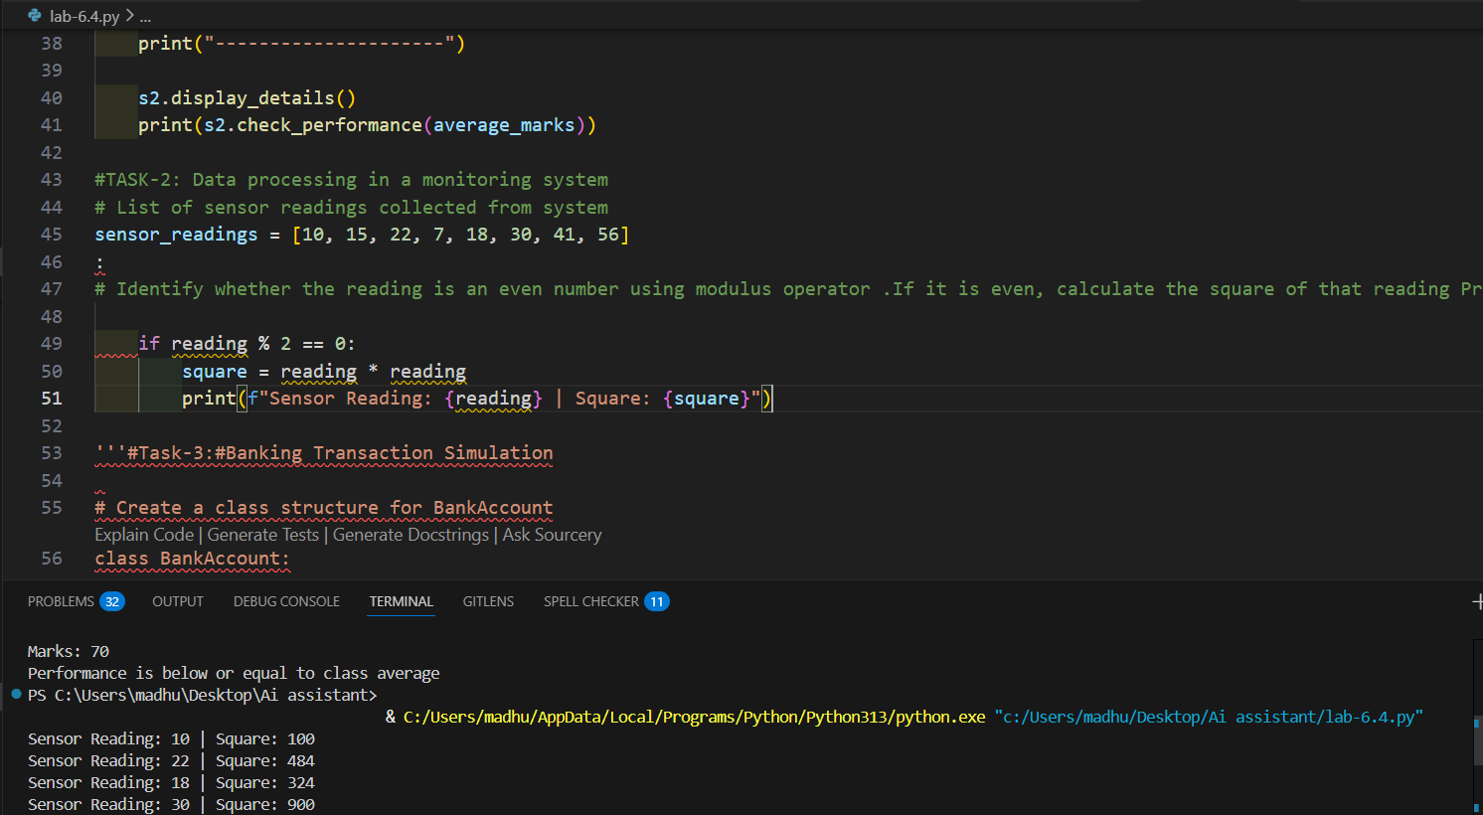
CODE ANALYSIS:
- The program checks each sensor value to see if it is even using the modulus (%) operator.
- If the number is even, it calculates the square of that number.
- Finally, it prints the original reading and its square in a clear format.

TASK-3: Banking Transaction Simulation
PROMPT:
Generate a code in python and Create a class structure for BankAccount. #Create a method to deposit money into the account.The method should take amount as parameter.Add the amount to balance and display updated balance.# Create a method to withdraw money.Check if sufficient balance is available using if-else.If balance is enough, deduct amount and print success message Otherwise print 'Insufficient Balance'. #Create a method to display account details
CODE:
# Create a class structure for BankAccount
class BankAccount:
def __init__(self, account_holder, balance):
self.account_holder = account_holder
self.balance = balance
# Create a method to deposit money into the account.The method should take amount as parameter.Add the amount to balance and display updated balance
def deposit(self, amount):
self.balance += amount
print(f"Deposit Successful! New Balance: {self.balance}")
# Create a method to withdraw money.Check if sufficient balance is available using if-else.If balance is enough, deduct amount and print success message Otherwise print 'Insufficient Balance'
def withdraw(self, amount):
if amount <= self.balance:
self.balance -= amount
print(f"Withdrawal Successful! Remaining Balance: {self.balance}")
else:
print("Insufficient Balance! Withdrawal Failed.")
# Create a method to display account details
def display_details(self):
print("Account Holder:", self.account_holder)
print("Current Balance:", self.balance)
# Sample Usage
if __name__ == "__main__":
# Creating a BankAccount object
account = BankAccount("Madhuri", 5000)
account.display_details()
print("\nPerforming Transactions...\n")
account.deposit(1500)
account.withdraw(3000)
account.withdraw(5000)
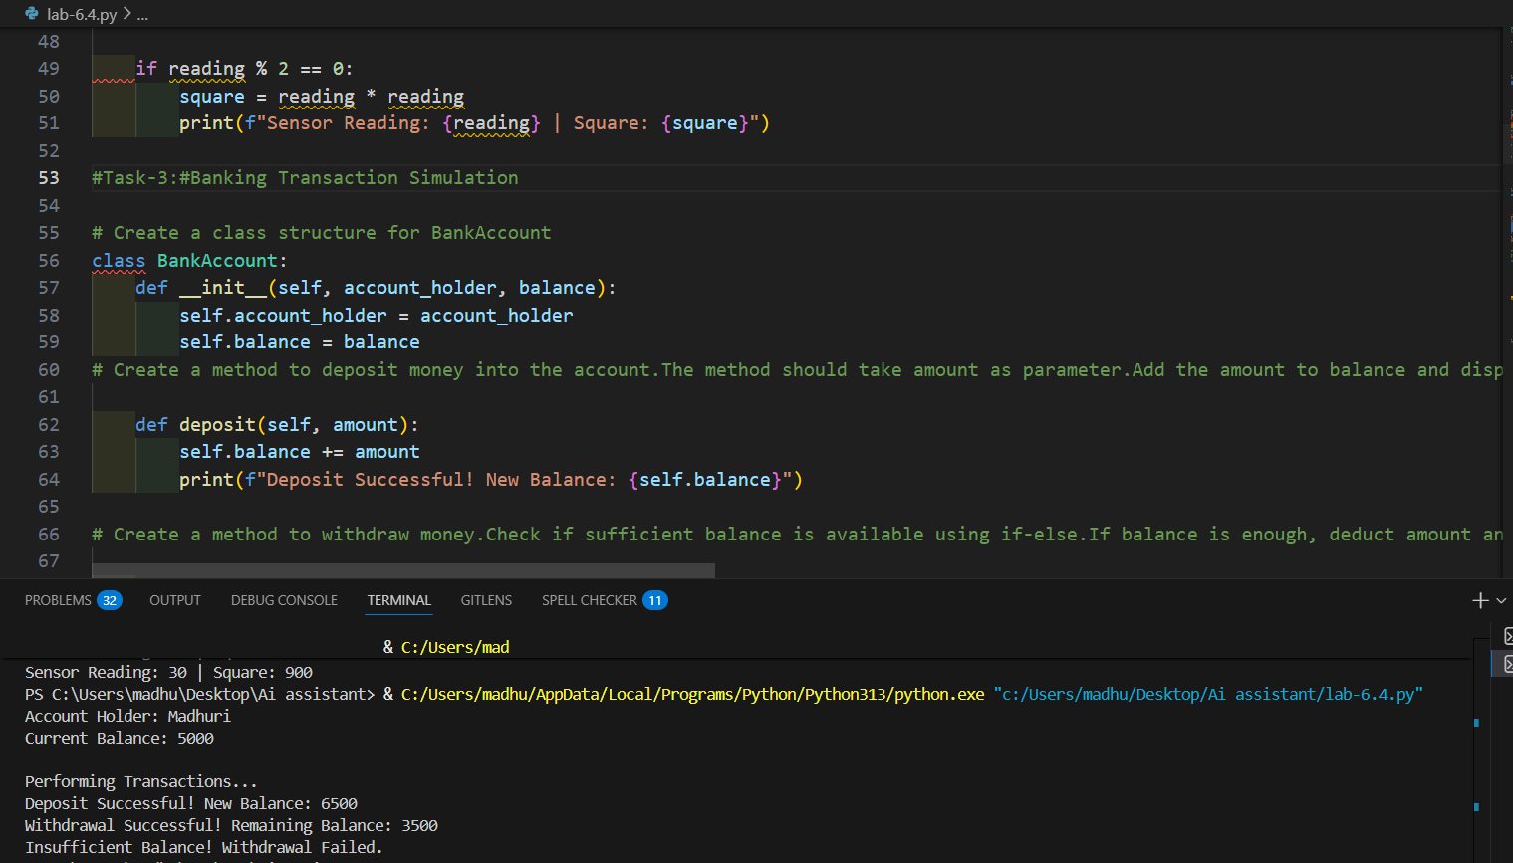
CODE ANALYSIS:
- The program creates a BankAccount class that stores account holder name and current balance.
- It includes methods to deposit money, withdraw money with balance checking, and display account details.
- The sample usage shows transactions like deposit and withdrawal working correctly with proper messages.

TASK-4: Student Scholarship Eligibility Check
PROMPT:
Create a Python program that defines a list of dictionaries containing student name and score.Then generate a while loop that iterates through the list, checks if the score is greater than 75, and prints the names of eligible students.Use proper index handling and conditional statements.
CODE:
#Create a Python program that defines a list of dictionaries containing student name and score.Then generate a while loop that iterates through the list, checks if the score is greater than 75, and prints the names of eligible students.Use proper index handling and conditional statements.
# Student Scholarship Eligibility Check
students = [
{"name": "Amit", "score": 82},
{"name": "Priya", "score": 74},
{"name": "Rahul", "score": 90},
{"name": "Sneha", "score": 68},
{"name": "Karan", "score": 77}
]
# Initialize index variable for while loop
index = 0
while index < len(students):
if students[index]["score"] > 75:
print(students[index]["name"], "is eligible for scholarship")
index += 1
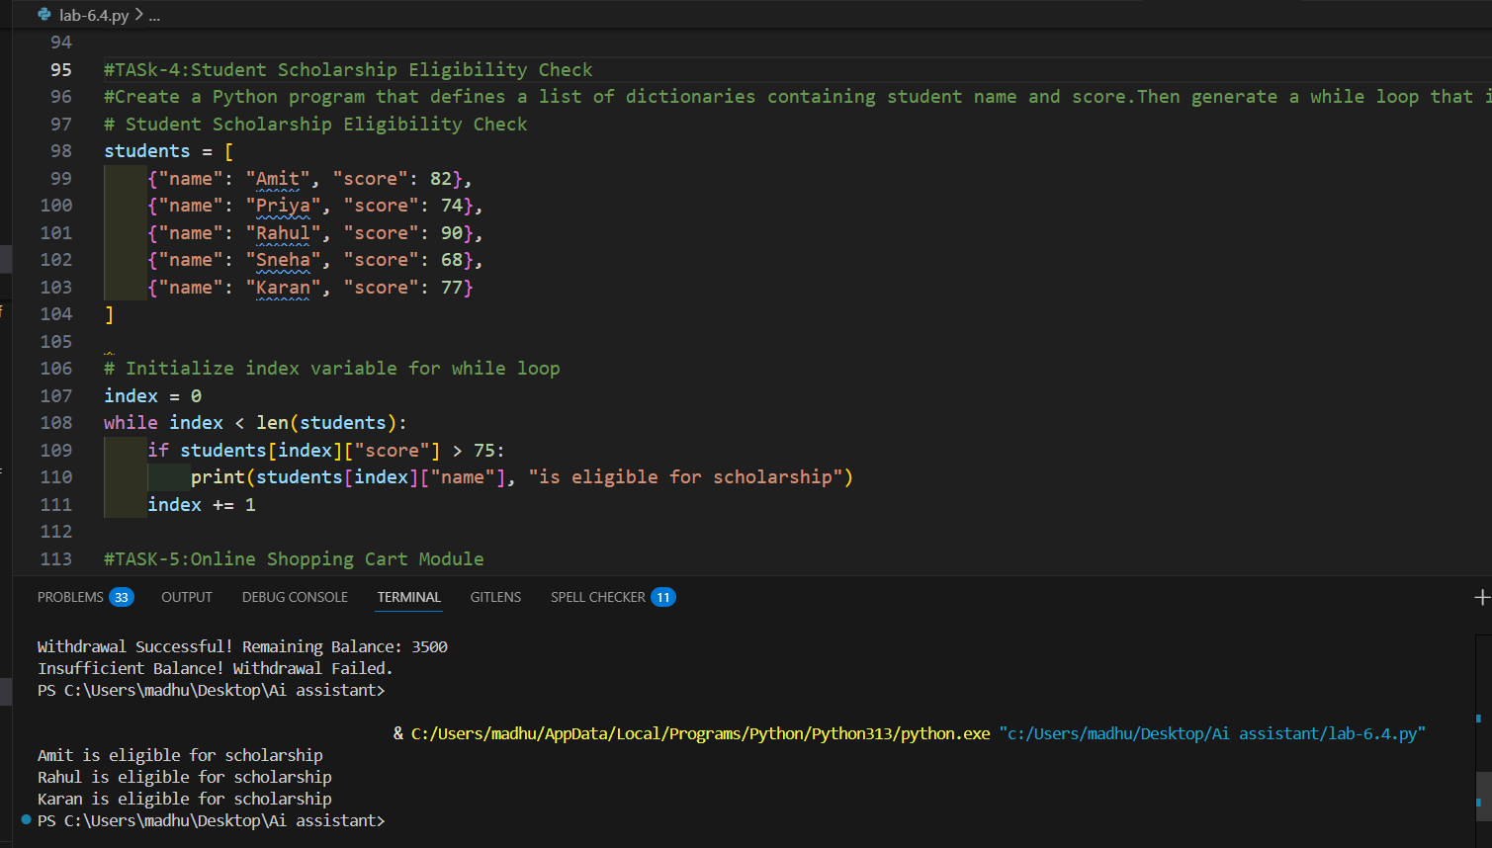
CODE ANALYSIS:
- The program stores student names and scores using a list of dictionaries.
- It uses a while loop to check each student one by one.
- if a student’s score is more than 75, their name is printed as eligible for scholarship.

TASK-5: Online Shopping Cart Module
PROMPT:
#create a Python class ShoppingCart with an empty list to store items.Generate methods to add items, remove items, calculate total bill using a loop, and apply discount if total exceeds a limit.Include sample usage to demonstrate cart functionality.
CODE:
class ShoppingCart:
def __init__(self):
self.items = []
def add_item(self, name, price, quantity):
item = {"name": name, "price": price, "quantity": quantity}
self.items.append(item)
print(f"{name} added to cart.")
def remove_item(self, name):
for item in self.items:
if item["name"] == name:
self.items.remove(item)
print(f"{name} removed from cart.")
return
print("Item not found in cart.")
def calculate_total(self):
total = 0
for item in self.items:
total += item["price"] * item["quantity"]
return total
def apply_discount(self):
total = self.calculate_total()
if total > 1000:
discount = total * 0.10
final_amount = total - discount
print(f"Discount Applied! Final Amount: {final_amount}")
else:
print(f"No Discount. Final Amount: {total}")
# Display cart items
def show_cart(self):
print("\nItems in Cart:")
for item in self.items:
print(item["name"], "-", item["quantity"], "x", item["price"])
# Sample Usage
if __name__ == "__main__":
cart = ShoppingCart()
cart.add_item("Laptop", 800, 1)
cart.add_item("Mouse", 200, 2)
cart.add_item("Keyboard", 300, 1)
cart.show_cart()
print("\nTotal Bill:", cart.calculate_total())
cart.apply_discount()
cart.remove_item("Mouse")
cart.show_cart()
print("\nUpdated Total Bill:", cart.calculate_total())
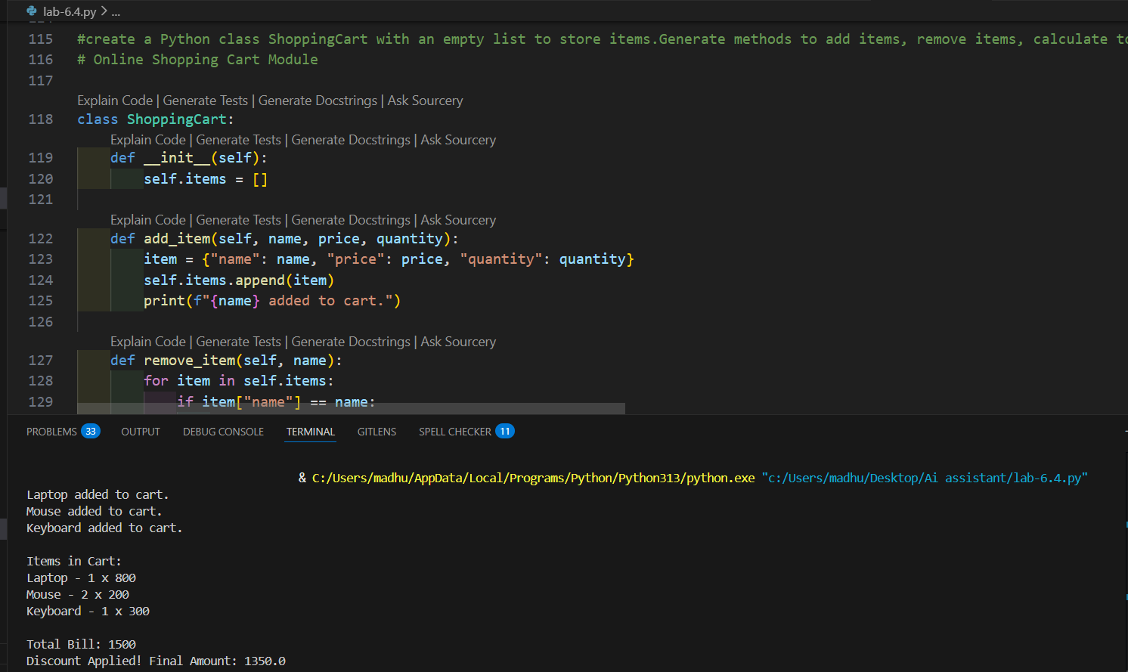
CODE ANALYSIS:
- The program creates a ShoppingCart class that stores items in a list with name, price, and quantity.
- It provides functions to add items, remove items, calculate total bill, and apply discount based on conditions.
- The sample usage shows the cart working correctly by adding items, showing cart details, and calculating the final amount.

